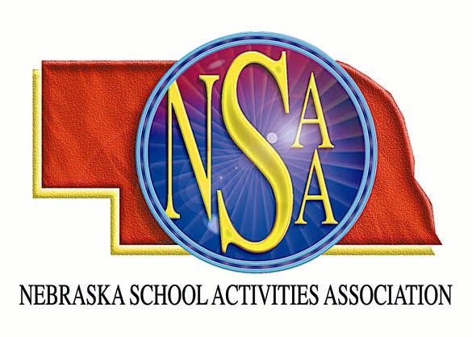
ENOA/NSAA FOOTBALL
OFFICIALS’ CLINIC &
RULES MEETING

The Eastern Nebraska Officials Association and Nebraska School Activities Association will sponsor a football officiating clinic at Lincoln East High School and Seacrest Field in Lincoln, Nebraska. There will be two Class A schools conducting an intra-squad scrimmage in the morning. Officials should come prepared to officiate. Knickers and socks are not required. Attendees will be divided into two groups for the morning sessions. Each group will have field time and classroom time. We will make every effort to accommodate crews.

Football Officials Clinic

Lincoln East High School

1000 South 70th
Saturday, August 11, 2007

Check In: 7:30 am – 8:00 am
Position Meeting: 8:00 am – 9:00 am
Scrimmage I/Classroom I: 9:15 am – 10:45 am
Scrimmage II/Classroom II: 11:00 am – 12:30 pm
Lunch (Provided): 12:30 pm – 1:00 pm
Clinician Forum: 1:00 pm – 2:00 pm
NSAA Rules Meeting: 2:00 pm – 3:00 pm
Q & A with Clinicians (optional): 3:00 pm – 4:00 pm

$ 25.00 Non-Refundable Registration Fee

Complete the registration form with all the necessary information and enclose payment of $25.00.
The fee is non-refundable. Return by August 1, 2007 SPACE IS LIMITED!

_________________________________________________________________________________________________

Name:_____________________________________

Address:___________________________________

City, State, Zip:______________________________

Telephone #:________________________________

E-mail:_____________________________________

Yrs. Experience:_____________________________

Position:____________________________________

MAIL TO: NSAA
Po Box 5447
Lincoln, NE 68505-0447

List names of attendees with whom you
prefer to be assigned:

___________________________________

___________________________________

___________________________________

___________________________________

___________________________________

